**TOP CLASS LESSON NOTES TERM I**

**LEARNING AREA I (SOCIAL DEVELOPMENT)**

**LEARNING OUT COME:**

Identifying, taking interest in ad observing people around me.

**Competence:**

The learner shows acceptable behavior to people in his / her immediate environment. E.g parents, guardians and their care givers.

**WEEK ONE**

Family members

***Activity 1***

**Draw people found at home.**

|  |  |  |
| --- | --- | --- |
| Father | Mother | Sister |
|  |  |  |
| Brother | Baby | Grandmother |
|  |  |  |

***Activity 2***

**Circle a word for a given picture.**

|  |
| --- |
| father mother sister |
| daddy sister brother |
| baby brother father |
| uncle mother aunt |
| brother uncle father |

**Activity 3**

**Match a word to picture**

Baby 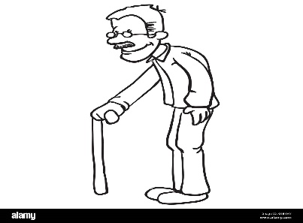

Grandmother 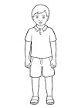

Sister 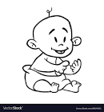

Father 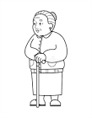

Brother 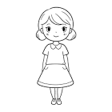

Grandfather 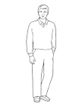

**Activity 4**

**Name these people at home**

    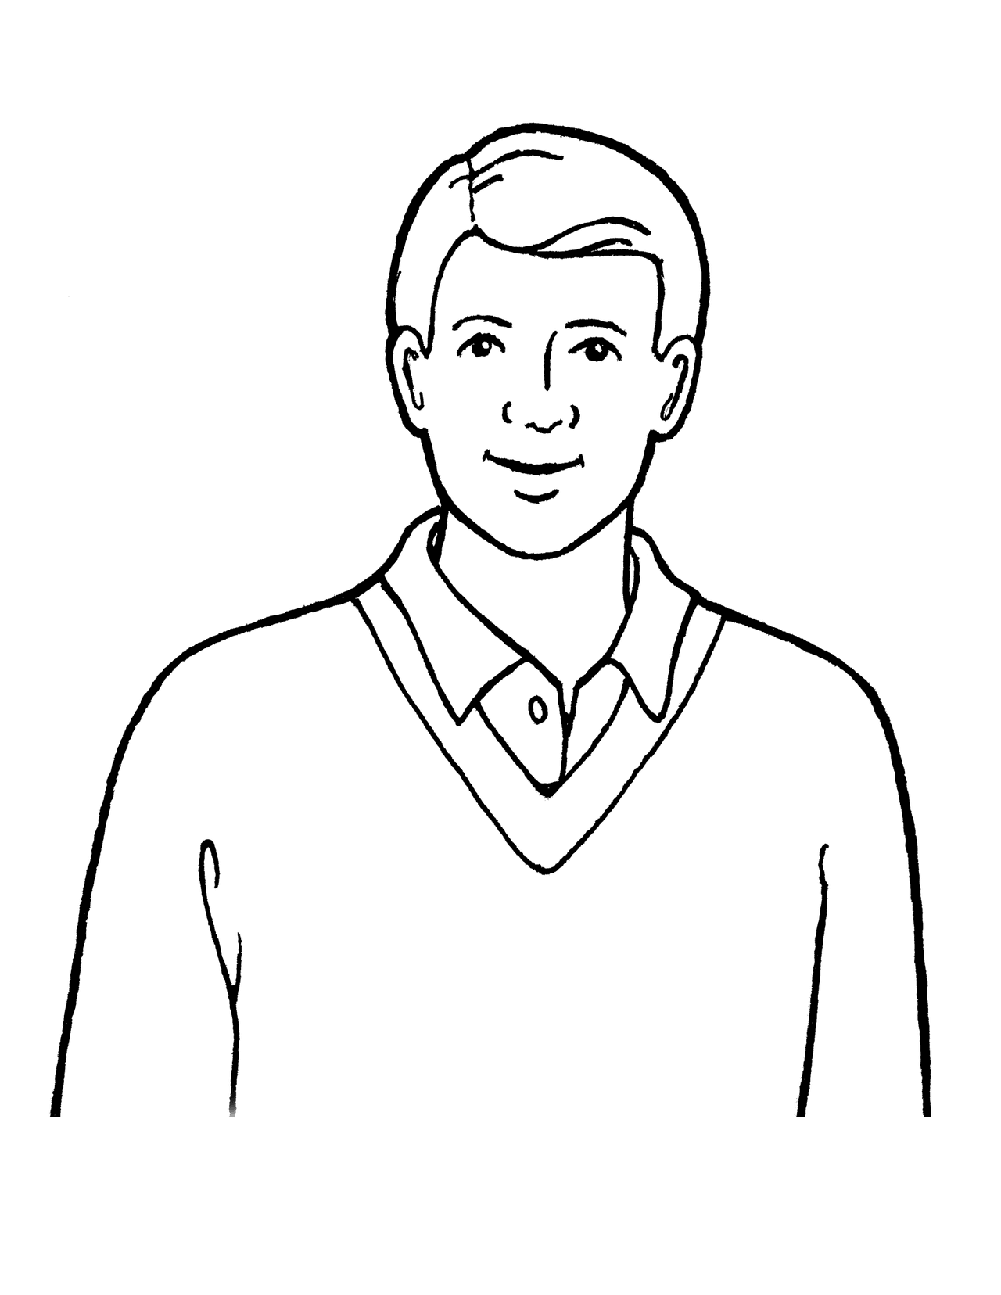 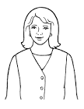 

**Activity 5**

**Circle the same words**

grandmother sister grandmother

uncle uncle aunt

grandfather mother grandfather

brother sister sister

father mother father

baby baby mother

**WEEK 2**

**Activity 1**

**Read and draw**

|  |  |  |
| --- | --- | --- |
| Father | Sister | Mother |
|  |  |  |
| Uncle | Grandfather | Brother |
|  |  |  |

**Activity 2**

**Fill in the missing letters**

F__ther gr___ndfather m__ther

u___cle s___ster b___by

**Activity 3**

**Name these people in the picture**

  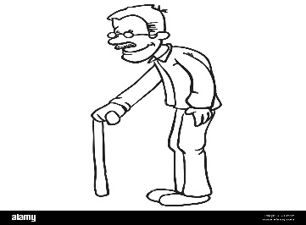   

**Activity 4**

**Read and draw**

|  |  |  |
| --- | --- | --- |
| Aunt | Grandfather | Uncle |
| Mother | Sister | Brother |

**Activity**

**Listen and write (metal work)**

Mother sister brother father baby uncle aunt grandmother grandfather

**WEEK 3**

**Things used (found) at home**

**Activity 1**

**Read and draw**

|  |  |  |
| --- | --- | --- |
| Cup | Plate | Kettle |
| Pot | Bed | Stool |

**Activity 2**

**Name these pictures**

|  |  |  |
| --- | --- | --- |
|  |  |  |
|  |  |  |

**Activity 3**

**Match the word to the picture**

Spoon 

Bed 

Chair 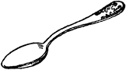

Basket 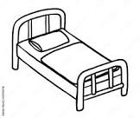

Mat 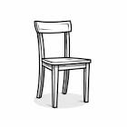

Television 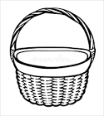

**Activity 4**

**Fill in the missing letter**

t___ble cha__r st___ ___ l

jerryc___n pl___te f___rk

**Activity 5**

**Listen and writ (metal work) all words**

table

chair

stool

plate

jerrycan

chair

fork

fan

mat

basket

bed

cup

**Week 4**

**Topic: people found at school / important people**

**Activity 1**

**Read and match the same words**

Teacher watchman / gateman

Bursar cook

Cook teacher

Cleaner bursar

Watchman /gateman cleaner

**Activity 2**

**Circle the same words**

Teacher nurse teacher

Cook cook imam

Bursar policeman bursar

Teacher gateman gateman

Children cook children

**Activity 4**

**Read and draw**

|  |  |  |
| --- | --- | --- |
| Teacher | Cook | Bursar |
| Children | School nurse | Cleaner |

**Activity 4**

**Name people found at school**

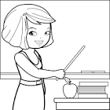 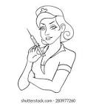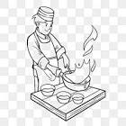 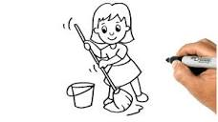 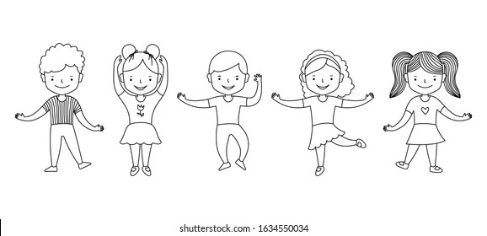

**Activity 5**

**Fill in the missing letters**

c___ ___k te___cher school nu___se watchm___n

b___rsar ch___ldren

**WEEK 5**

**Topic: Things found in class or at school**

**Activity 1**

**Match the same words.**

pencil tin

book table

desk pencil

ruler book

table desk

tin ruler

**Activity 2**

**Circle words of things found in class.**

table bag mat

pen axe desk

flower pencil

chalk ruler bench

**Activity 3**

**Read and draw**

|  |  |  |
| --- | --- | --- |
| table | Pencil | Bench |
| bag | Ruler | Book |

**Activity 4**

**Name things found in the classroom**

 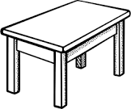 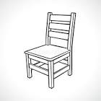 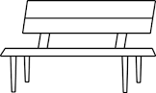 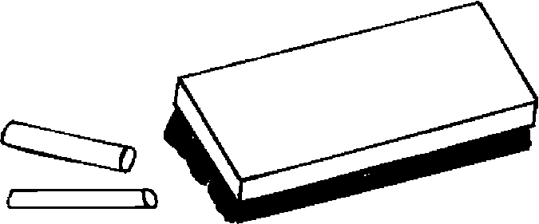

**Activity 5**

**Name things found in the classroom**

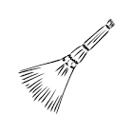 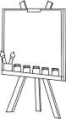 

  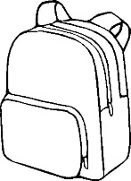

**WEEK 6**

**People in the environment / important people**

**Activity 1**

**Read and draw**

|  |  |  |
| --- | --- | --- |
| Teacher | farmer | nurse |
| Policeman | doctor | imam |

**NOTE:**

Things used by important people must be done daily in oral work before the new lesson starts to avoid repetition of things.

e.g

1. What does a farmer use to dig? Hoe.
2. A doctor uses an injection, medicine to treat people
3. A policeman keeps us safe with a gun.
4. Help them to spell these words etc

**Activity 3**

**Underline the important people**

policeman church teacher

house cook doctor

tin farmer gate

imam dog priest

nurse belt people

**Activity 4**

**Fill in the missing letter**

te___cher c___ok f___rmer n___rse d___ctor Im___m

**Activity 5**

**Complete the story**

Tom is a ___________he goes to the ________________every morning.

He carries a _______________. Tom grows ___________, __________ and _____

**{hoe, carrots, garden, farmer, apples, oranges}**

**WEEK 7**

**Important places**

**Activity 1**

**Circle the same words.**

church pot church

hospital hospital tin

egg school school

mosque gate mosque

flower garden garden

**Activity 2**

**Read and draw**

|  |  |  |
| --- | --- | --- |
| Church | Hospital | School |
| Garden | Mosque | Police station |

**Activity 3**

**Name the pictures.**

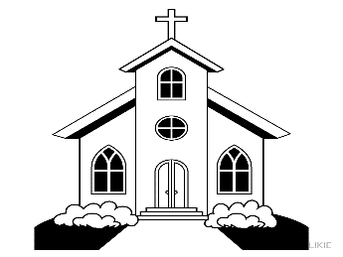This is a __________________

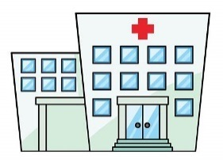This is a __________________

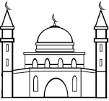This is a __________________

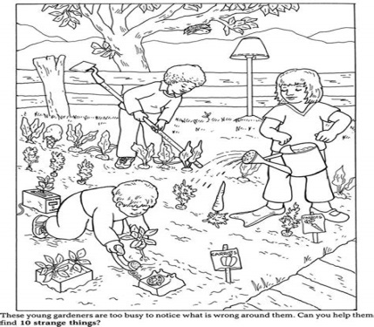This is a __________________

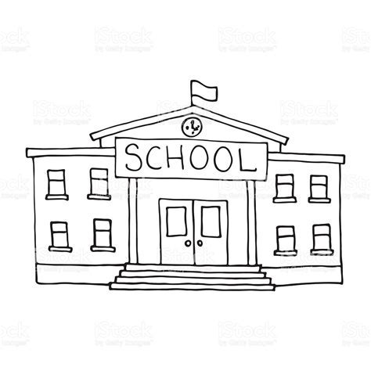This is a __________________

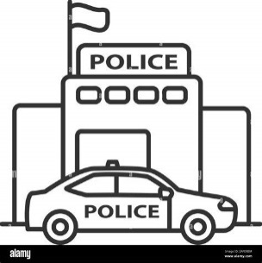This is a __________________

**Activity 4**

**Fill in the missing letter**

ch___rch sch__ ___l m___sque

g___rden h____spital police st____tion

**Activity 5**

**Match people to their place of work**

doctor police station

teacher church

farmer mosque

Imam hospital

priest school

policeman garden

**Pupils paper work**

**Complete the story**

Jane is a ___________________she goes to her ______________every morning. She uses ________________to treat _________________

**{medicine, clinic, nurse, sick people}**

**Week 8**

**Things people use for transport**

**Activity 1**

**Read and draw**

|  |  |  |
| --- | --- | --- |
| Aeroplane | bus | taxi |
| train | lorry | motorcycle |

**Activity 2**

**Read and draw**

|  |  |  |
| --- | --- | --- |
| Bicycle | Boat | Ship |
| Horse | Car | Truck |

**Activity 3**

**Read and match**

Lorry 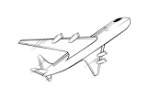

Bus 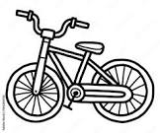

Aeroplane 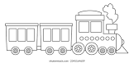

Bicycle 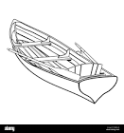

Boat 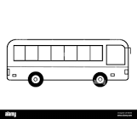

Train 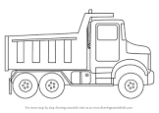

**Activity 4**

**Name the pictures**

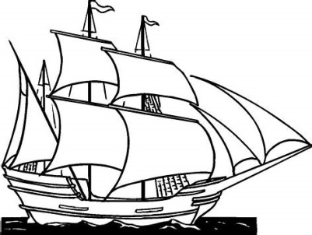 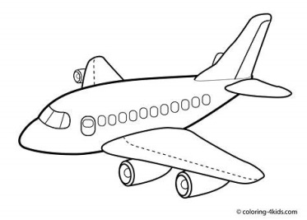

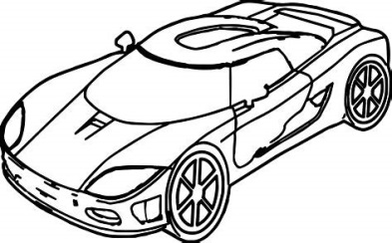  

**Oral questions**

* What is your name?
* Tell me the people found at school
* Who flies an aeroplane?
* Who keeps law and order?
* Who treats sick people?
* Who teaches children at school?
* What is the work of the bursar?
* How do you show good behaviour to others?
* Who heads a school?
* What is the work of the teacher, doctor, policeman, farmer etc.
* Where do you find a doctor, priest, nurse, teacher, watchman, cook etc